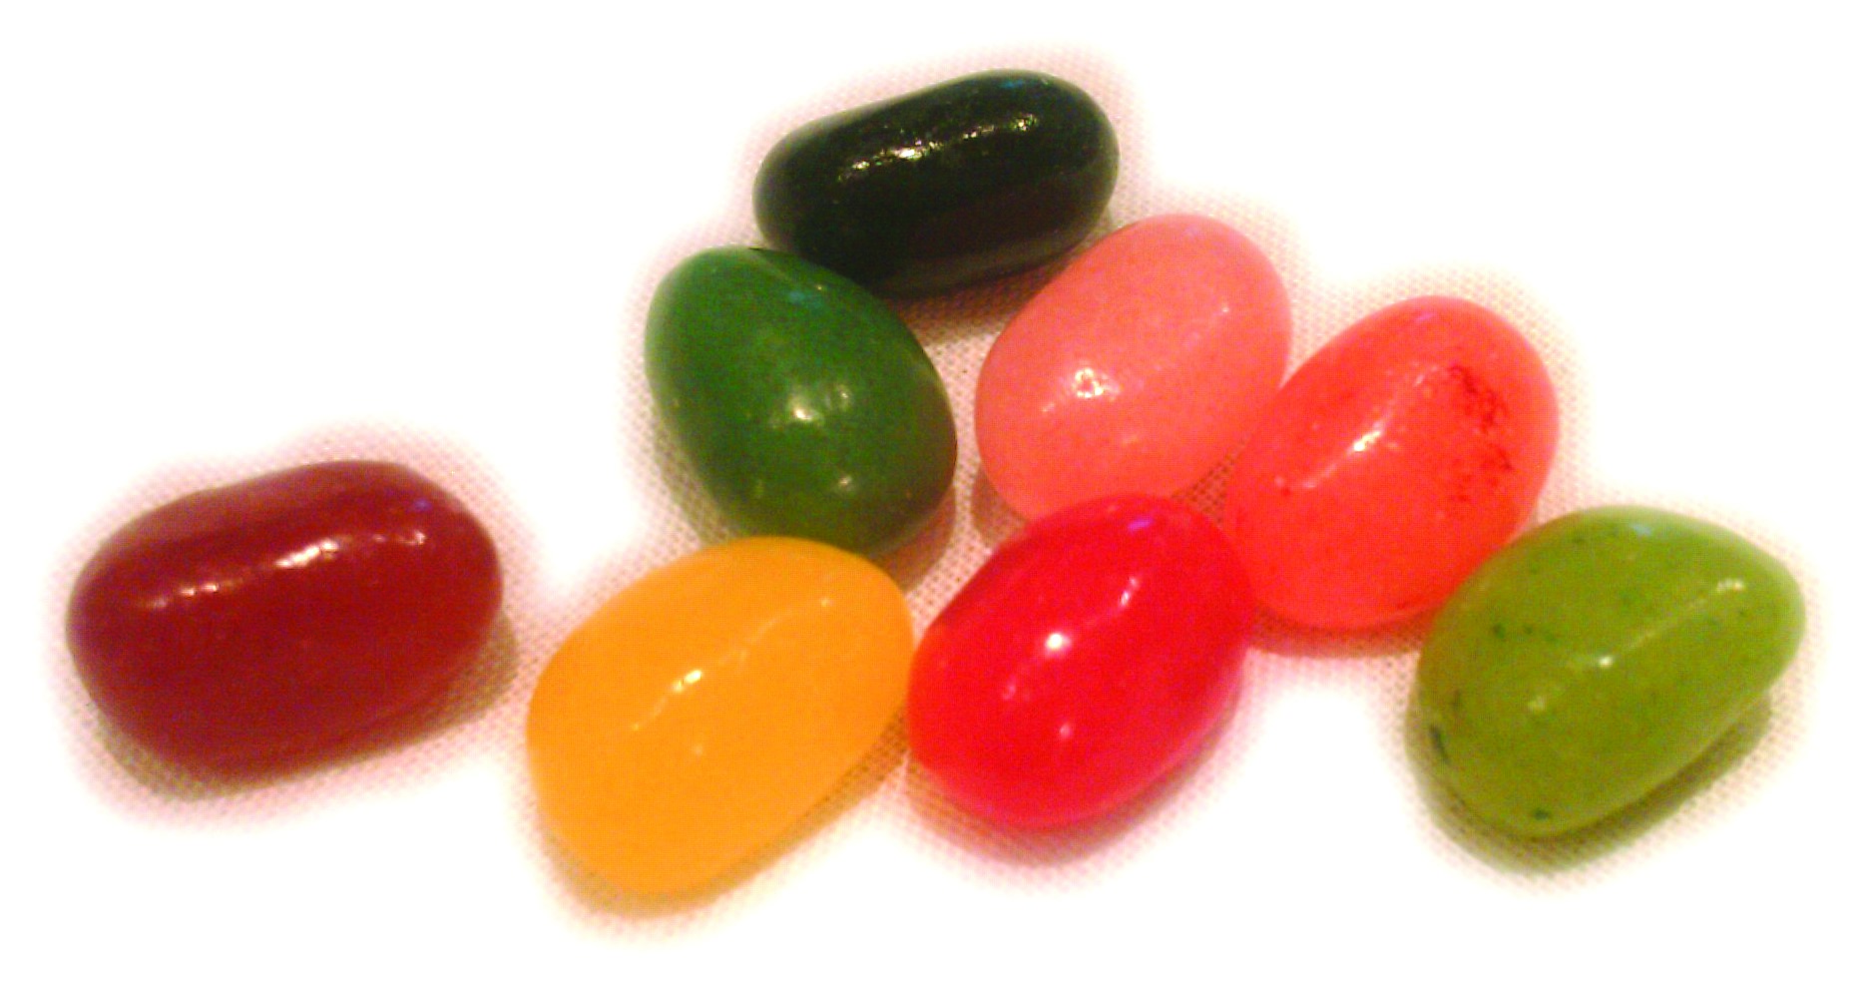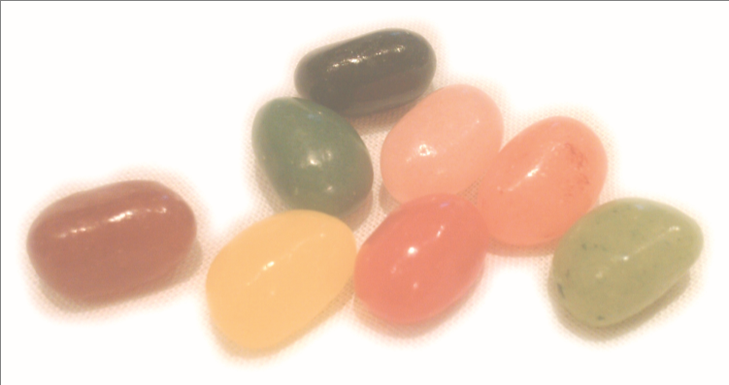

For more information:

<https://www.nutrition.org.uk/press-office/pressreleases/healthylunchbox.html>

<https://www.bbcgoodfood.com/howto/guide/10-healthy-lunch-ideas-kids>

<https://www.nhs.uk/change4life/recipes/healthier-lunchboxes>

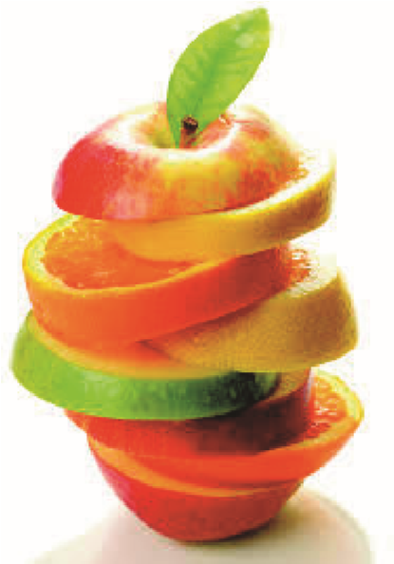



**Jelly Beans**

# Pre-school

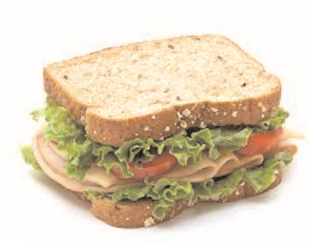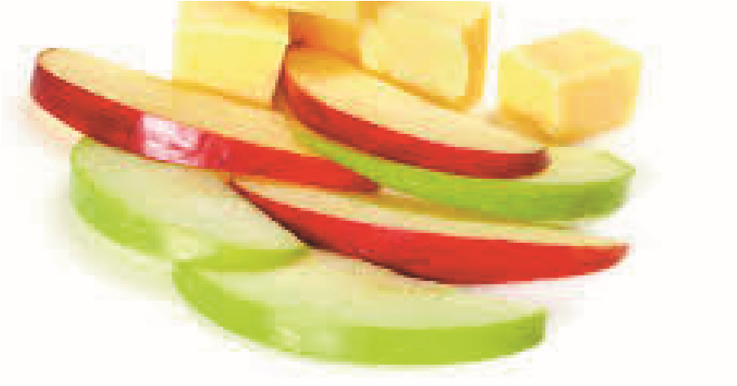**Guide to a Healthy Packed Lunch** Jelly Beans Pre-school supports the benefits of a well-balanced meal in the middle of the day.

**A child’s lunch should include:**

The main portion of the lunch should include starchy food such as bread, roll, pitta bread, crackers, chapati, pasta, rice, couscous or potatoes (choosing wholegrain, wholemeal or brown provides more fibre and wider range of nutrients)

Fresh fruit and vegetables, e.g. apple, orange, banana, cherry tomatoes, carrot sticks and/or mini fruit chunks. Aim for at least 5 portions a day. Add salad or cucumber to sandwiches or vegetables to a pasta or rice salad  
  
A portion of milk or dairy food, e.g. cheese, yoghurt (Low in sugar variety)  
  
Portion of protein- lean meat, fish, pulses, beans, eggs eg. tuna, chicken or hummus.  
  
We provide milk and water- we do not require you to provide a separate drink in your child’s lunch box.

**A child’s lunch should not include:**

**Sweets**, e.g. Haribos, chocolate bars.- not fair on other children

Fizzy drinks.

Foods **containing nuts**, e.g. peanut butter spread and Nutella, as **we are a nut free pre-school.**

Please label all lunchboxes and Tupperware boxes.

**Please be aware of:**Hidden Sugar, e.g. one large Capri Sun contains 1 1/2 teaspoons of sugar hence we now offer water and milk only.  
  
Check the label; drinks with no added sugar will have artificial sweetener (aspartame) - not recommended for young children.  
  
Items can be high in sugar if it contains more than 10g of sugar per 100ml. Items are low in sugar if it contains less than 2g of sugar per 100ml.   
  
Hidden salt, e.g. processed cheese like cheese strings, crisps.  
  
Ensure that the quantity of food provided by is not too much and portion size is appropriate.

**Here are some healthy lunch box ideas:**Making swaps, e.g. instead of a chocolate bar, give them raisins or a pot/chopped fruit. Instead of savoury crisps, give them plain popcorn, pom bears, baked crisps, rice cakes, bread sticks or carrot sticks.  
  
Choose low fat sandwich fillings, e.g. lean meats like chicken or turkey, fish like tuna or salmon, cheese like edam, mozzarella or cottage cheese, or sliced banana.  
  
 Dairy is good for growing bones, e.g. yoghurt, low fat custard, fromage frais or rice pudding. We provide free milk.